1.INTRODUTION

1.1Overview

Project Description

**A subscriber to a channel on the video-sharing YouTube is a user who has chosen to receive the channel's content by clicking on that channel's "Subscribe" button, and each user's subscription feed consists of videos published by channels to which the user is subscribed. The ability to subscribe to users was introduced in October 2005. YouTube began publishing a list of its most- subscribed channels in April 2006. An early archive of the list dates to May 2006.**

**The following table lists the 50 most-subscribed YouTube channels, as well as the primary language and content category of each channel. The channels are ordered by number of subscribers; those whose displayed subscriber counts are identical are listed so that the channel whose current growth rate indicates that its displayed subscriber count will exceed that of the other channel is listed first. Automatically generated channels that lack their own videos (such as Music and News) and channels that have been made effectively obsolete as a result of the transferal of their content (such as Justin Bieber VEVO and Taylor Swift VEVO) are excluded. As of February 2023, 21 of the 50 channels listed primarily produce content in English while 16 primarily produce content in Hindi. All 50 of the channels have surpassed 40 million subscribers, 39 of them have surpassed 50 million subscribers, 23 of them have surpassed 60 million subscribers, 16 of them have surpassed 70 million subscribers, 12 of them have surpassed 80 million subscribers, 10 of them have surpassed 90 million and 7 of them have surpassed 100 million subscribers. Only 1 channel (T-Series) has surpassed 200 million subscribers.**

1.2 purpose

**The main purpose of YouTube is to provide a platform for users to watch, share, and create videos. In the last decade, YouTube has just become the most popular video-sharing platform in the world.**

**PROBLEM DEFINITION & DESIGN THINKING**

**2.1 Empathy Map**

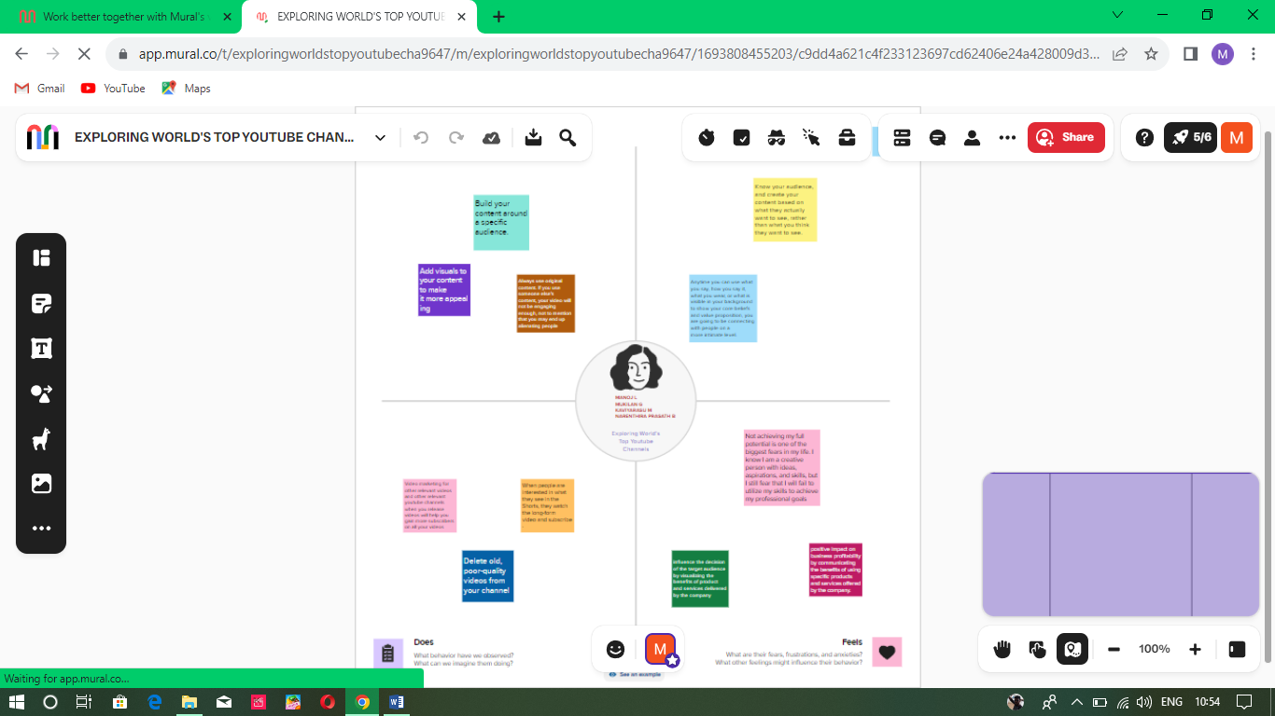

**2.2 Brainstroming Map**

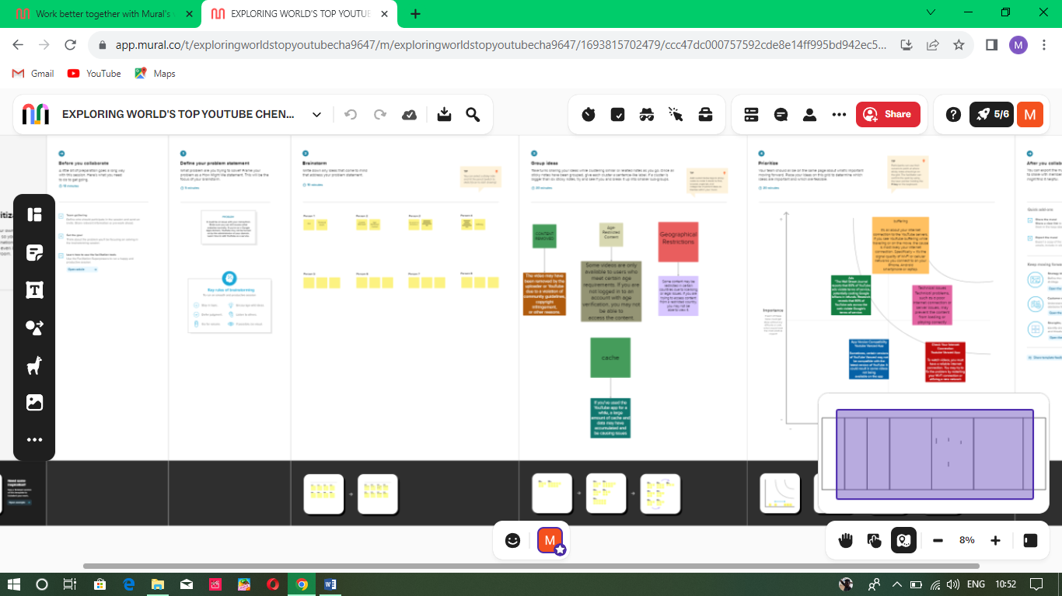

**RESULT**

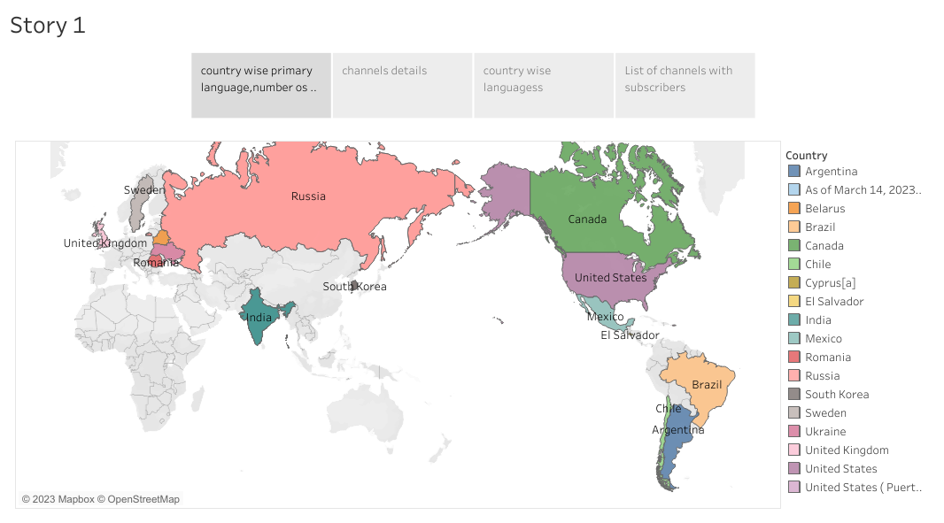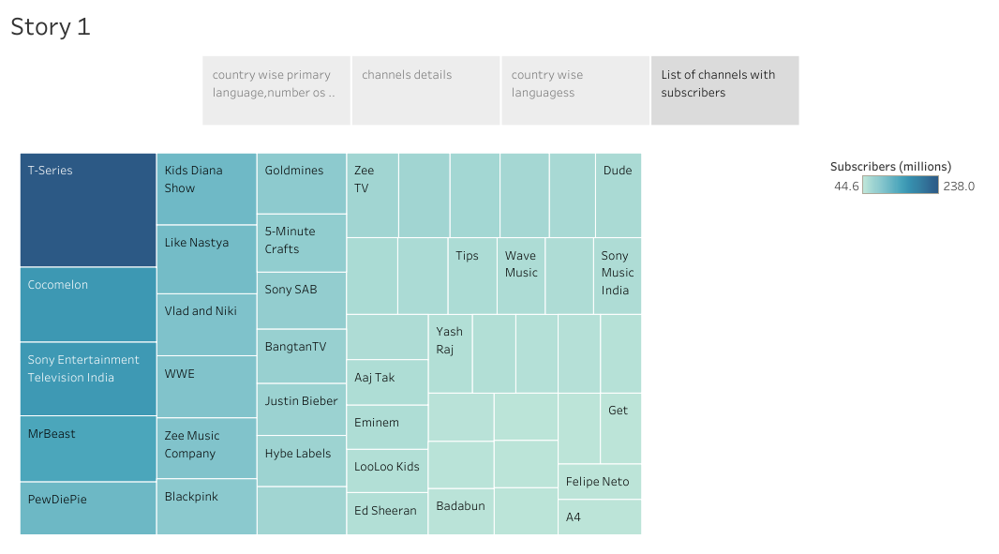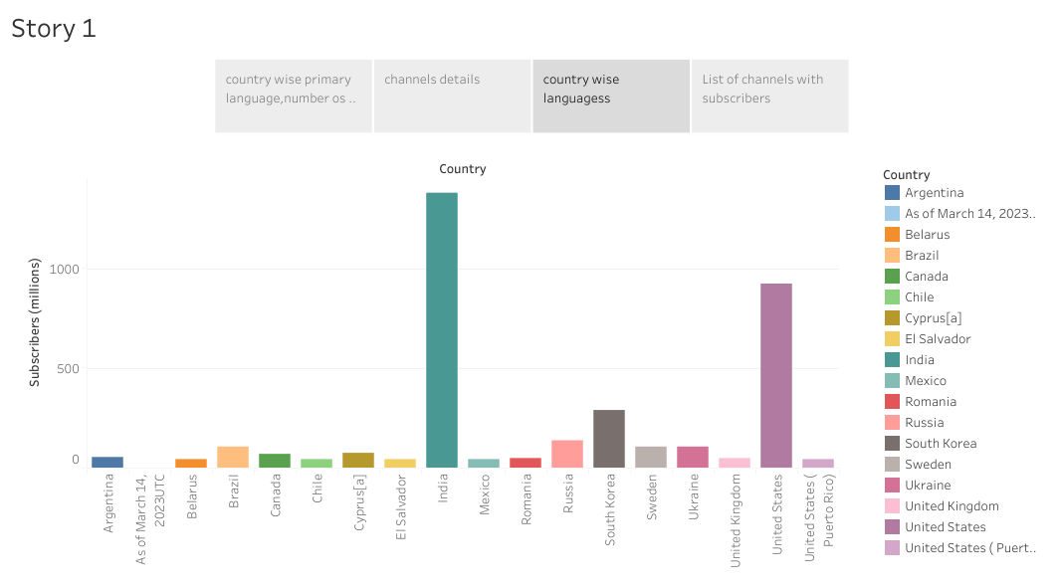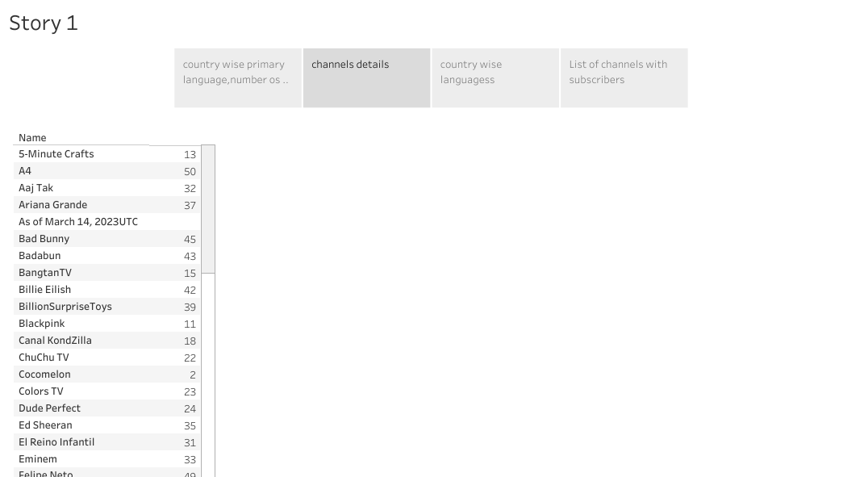

**ADVANTAGES & DISADVANTAGES**

**1. YouTube as an information disseminating platform for students**

**Advantages and Disadvantages of YouTube**

**It's the perfect place to learn and gain expertise. With online videos and "how to do" tricks, gaining knowledge is simple. In the process, YouTube is now the second largest source of information after Google. According to the most recent data, YouTube has around 2.3 billion active users as of 2021.**

**Millions of viewers watch YouTube videos daily, and more than 70 percent of YouTube watching is on mobile devices. There are many YouTube benefits for students in the automotive, IT engineering, financial and Medical fields. There is an expert YouTube channel for every area.**

**2. YouTube's user-friendliness**

**If you're interested in food, religion, culture, or parenting tips, there's a channel on YouTube that will offer online help. It's not just for professionals or pupils; YouTube is made for anyone to find what they enjoy. From pet lovers to homemakers, anyone can find content suitable to their interests. YouTube will keep the content informative and stimulating.**

**3. YouTube for Brand Promotion**

**YouTube videos have been an effective branding method for many businesses, especially during the lockdown. There are a lot of promotional videos from major business companies such as Redbull, shopping mode, Apple, BMW, Motorola, and many more.**

**With thousands of people using the platform, they are potential buyers too. Building a brand is the simplest method on the top platform. Millions of companies use this method, whether directly or through collaboration with influencers.**

**4. YouTube benefits talented people**

**If you think that you're specializing in something, then you are worthy of attention. The time is right to launch your own channel and be awestruck by viewers from all over the world. DIY and craft projects are searched for constantly. YouTubers with millions of subscribers show off their expertise by creating stunning projects, whether it's woodworking or Scotty Kilmer's automotive techniques. All you need to do is be focused on your passions and then roll out your ideas in videos that demonstrate how your work is beneficial in everyday life.**

**5. Easy Earning is at the very top of the list of YouTube benefits for Vloggers**

**Everyone is interested in the opportunity to turn their passion into a profit. This is exactly the kind of thing Youtube can offer any creator who has viewers. If your channel is populated with viewers and interesting content, you'll benefit the most from a YouTube Channel.**

**You can make money through your YouTube channel after it has reached the point of eligibility. It's easy to upload your content on the platform, and you can handle it all on your own. It is not necessary to invest in expensive equipment or accessories.**

**DISADVANTAGES**

**Disadvantages of YouTube**

**Apart from the advantages and benefits, there are also some negative aspects of YouTube for both YouTubers and viewers. There have been numerous instances have been reported concerning content censorship because it is detrimental to students as well as society. The following elements can be attributed to the negatives of Youtube from various points of View-**

1. **Ads- a drawback of YouTube for the audience**

There are some distinct disadvantages of watching YouTube videos, which include a lot of commercials. It is possible to skip your mainstream. However, you're often required to watch commercials lasting between 15 and 20 seconds. This isn't just a time-waster, but it can be irritating at times. Another issue that is associated with YouTube is that it requires you to pay a charge if you would like to view ads-free content.

1. **A lot of distraction**

The platform is updated with new content each minute, making it difficult to avoid engaging and interesting videos. When you begin viewing Youtube videos, you'll be able to continue watching more videos in the "Related Videos" section.

According to research done by the collective, the issue of distraction while driving can be a worldwide problem that kills and injures thousands of people each year. There are fatal outcomes of driving while being distracted by videos that depict a negative image of YouTube. Distraction is one of the most common disadvantages of YouTube for drivers, students, or even workers.

**3. Obscenity- one of the biggest drawbacks that YouTube has**

The kind of content that is uploaded on YouTube is largely in control today. The amount of people uploading videos has grown in the past five years, and it's becoming challenging for parents, as well as YouTube, to review the content. Since YouTube is a no-cost and accessible platform for anyone, children are attracted to watching videos with explicit language and obscenity.

The use of explicit images and words is common nowadays. This kind of content can be removed only when someone is notified about it. In general, YouTube acts faster against copyright issues that are reported. There are many negatives when the viewers are children as they are merely aware of how to report the issue.

**4.Defamation and Bullying**

It's a tool that helps the public notice you; untrustworthy people may use YouTube to harm other people's image in public. The public has begun to consider YouTube as a potential social media, particularly over the past five years.

However, YouTube also enables people to do socially interaction. While they communicate, any conversation which occurs may be considered cyber-bullying. The easiest method to reach someone on YouTube is via the comment area.

However, many users misuse the platform to spread hate and chaos via content, causing tension between users. This is even when Google requests that users be respectful in their comments.

**5. Making money isn't that easy**

You can sign up for a YouTube affiliate or partner program to earn. However, to be eligible for these programs, you'll need to have at minimum 1000 subscribers as well as 4,000 watching hours over the last twelve months. If you're unable to achieve this, it will come with more drawbacks to YouTube than benefits.

While it's an easy and efficient method of earning money, it won't be as if it's growing on trees. YouTube has an algorithm that will scrutinize and validate every channel's legitimacy before allowing it to be played. Therefore, if you decide to play in a way that is not legitimate, YouTube has the algorithm to catch such activities too.

5.APPLICATION

The responsiveness and design of a dashboard for Data-Driven insights on YouTube channels Analysis is crucial to ensure that the information is easily understandable and actionable. Key considerations for designing a responsive and effective dashboard include user-centered design, clear and concise information, interactivity, data-driven approach, accessibility, customization, and security. The goal is to create a dashboard that is user-friendly, interactive, and data-driven, providing actionable insights.

**CONCLUSION**

In conclusion, YouTube has evolved from a content sharing website to a platform for creating usergenerated content. An analysis of popular YouTubers explains why viewers find videos from Helbig, Sugg, and Kjellberg entertaining. Regardless of the category they represented, the trip all shared similar video elements including filming location, an uploading schedule, and video length. YouTube is the world’s third most popular online destination because viewers, especially those of a younger demographic, can relate to the authenticity of user-generated content. In addition to their own content, popular YouTubers are utilizing traditional media to build their personal brand. They can be found on bookshelves, on the television screen, and even in a wax museum. This study had its limitations. The sample size of this study was small. If the size was larger, more data could have been collected that would have further explored the similarities and differences that popular YouTubers share. This study did not focus on the audience of each YouTuber. Future research could be conducted among different age groups to gain more perspective about what viewers like and dislike about user-generated content.

**FUTURE SCOPE**

YouTube will likely become a destination for viewers and not just a place for people to find videos. YouTube will distribute its content directly to televisions, personal computers, and phones. It will also sell advertising based on this traffic.